**Bug Report**

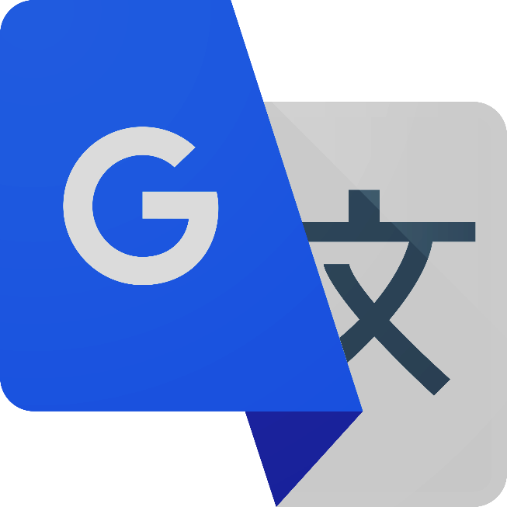

**Google Translate**

**Created By: W Shanali Nipunika Fernando**

**Date: 15/03/2024**

**Title/Summary:** Functionality Test for Input Tools - Handwriting Recognition

**Bug ID/Reference Number:** BUG-001

**Severity/Priority:** High priority, Major impact

**Description**: This bug occurs when the handwritten word is not recognized correctly and displayed the same text that is input in the text section.

The handwritten word is not translated into the text section.

**Steps to Reproduce:** Handwritten all capital word Choose a different language for the input language you want to translate

**Select Defect Language in the input section**

* Navigate to the Google Translate web application.
* Click on the input section.
* Select "Detect language" as the input language.
* Activate the handwriting input method.
* Click the Turn on handwriting.
* Use a stylus or mouse to write all capital word in the provided handwriting board.
* Move the cursor to the text field.
* A candidate word should appear under the handwriting board.
* Click on the candidate sentence.
* Verify that the selected sentence is displayed in the text field.

**Screenshots/Attachments:**

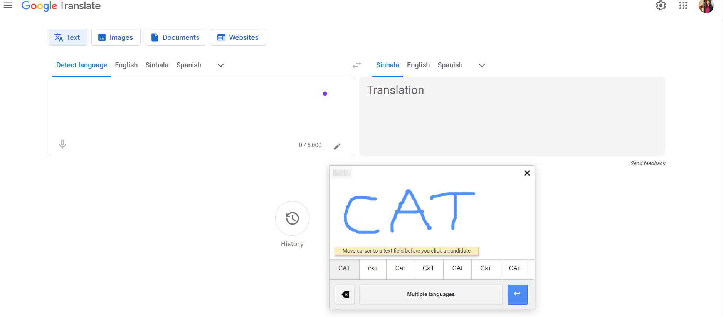

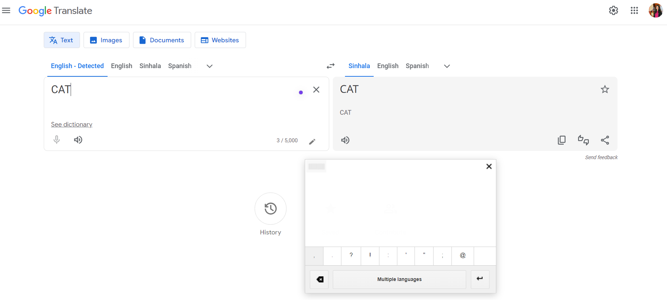

**Environment:**

**Operating System:** Windows 11

**Browser:** Google Chrome (Version 98.0.4758.102)

**Test Case Reference:** TC_TXTINPUT_15

**Title/Summary: Incorrect translation of text from English to Sinhala**

**Bug ID/Reference Number:** BUG-002

**Severity/Priority:** High priority, Major impact

**Description:** The translation from English to Sinhala is incorrect for certain text inputs in the Google Translate application. This issue arises when specific English phrases or sentences are translated into Sinhala inaccurately, resulting in a mismatch between the original meaning and the translated text. This discrepancy undermines the reliability and accuracy of the translation service, potentially leading to misunderstandings or miscommunication for users relying on the Sinhala translation.

**Steps to Reproduce:**

* Navigate to the Google Translate web application.
* Select English as the input language and Sinhala as the translation language.
* Input the text " Hi, I'm full with work today. Can you assist me with it??" in the input field.
* Click the Translate button.
* Actual Behavior: The translated text appears as " ආයුබෝවන්, මම අද වැඩ වලින් පිරිලා. ඔබට මට එයට උදව් කළ හැකිද?" which is incorrect.
* Expected Behavior: The translated text should accurately read " මට අද වැඩ ගොඩි, ඔයාට මට උදව් කරන්න පුලුවන්ද?".

**Screenshots/Attachments:**

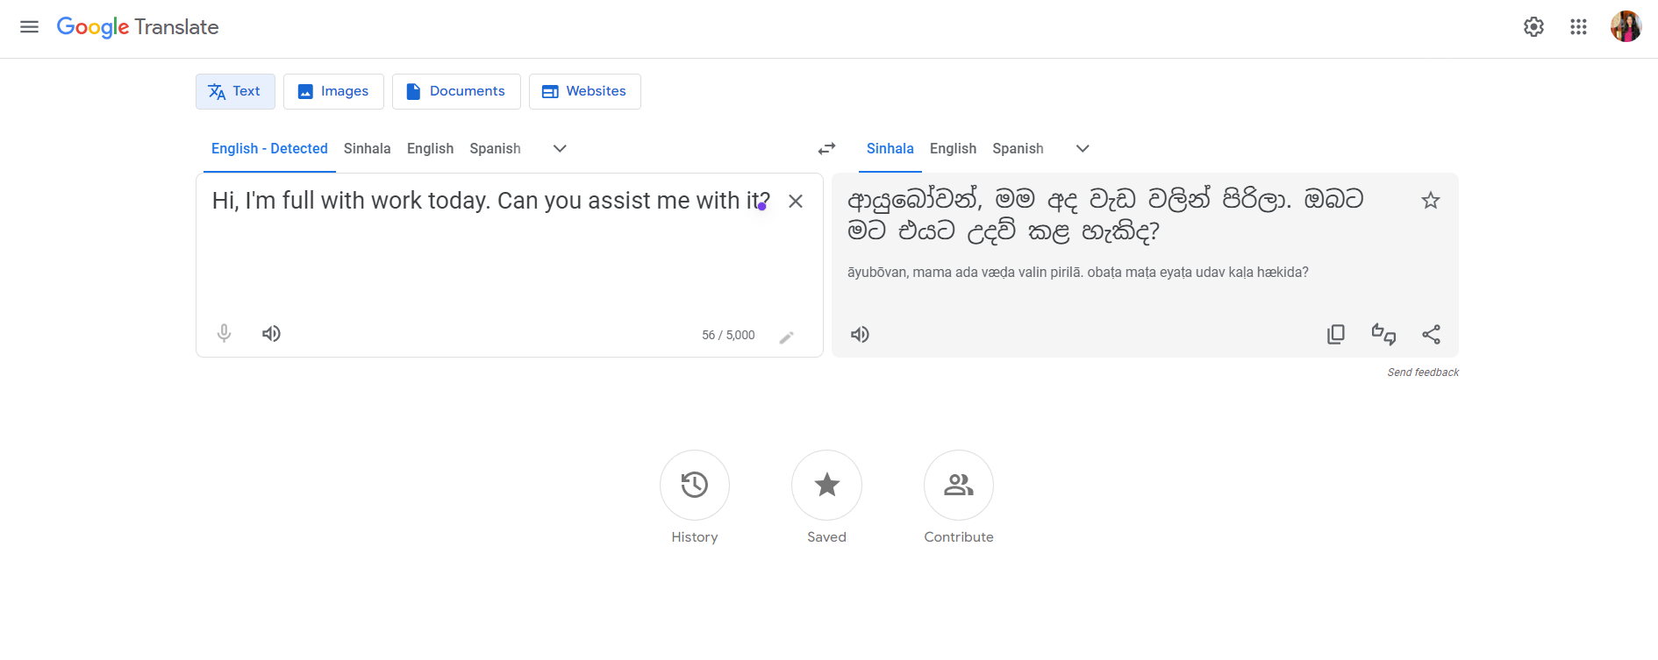

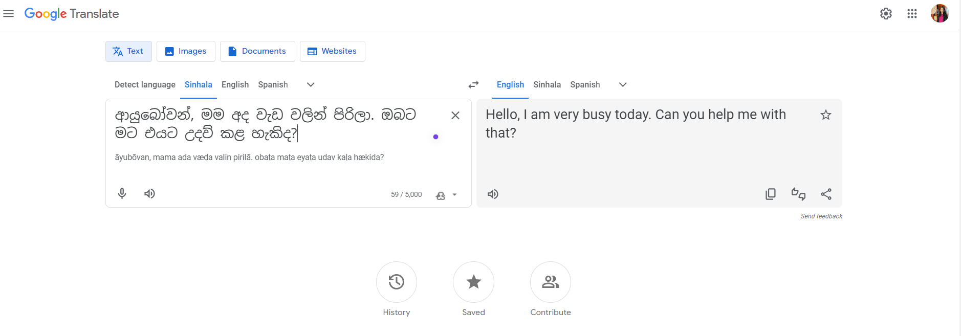

**Environment:**

Operating System: Windows 11

Browser: Google Chrome (Version 98.0.4758.102)

Test Case Reference: TC_TRANS_11

**Additional Information:**

This bug occurs consistently whenever translating from English to Sinhala.

No error message is displayed.

No known workaround currently exists.

Assigned To: Development Team

**Title/Summary:** Functionality Test for Input Tools - Virtual Keyboard

**Bug ID/Reference Number:** BUG-003

**Severity/Priority:** High priority, Major impact

**Description:** Without Move the cursor to the text field there is a no error message pop up.

**Steps to Reproduce:**

* Typed characters from the virtual keyboard.
* Navigate to the Google Translate web application.
* Click on the input section.
* Select a language.
* Click on the "Input tool" icon.
* Choose "Virtual keyboard" from the dropdown menu.
* A virtual keyboard should appear with all the characters.
* Move the cursor to the text field.
* Use the virtual keyboard to type characters and form a word.
* Click on the word you formed using the virtual keyboard.
* Verify that the selected word is displayed in the text field.

**Screenshots/Attachments:**

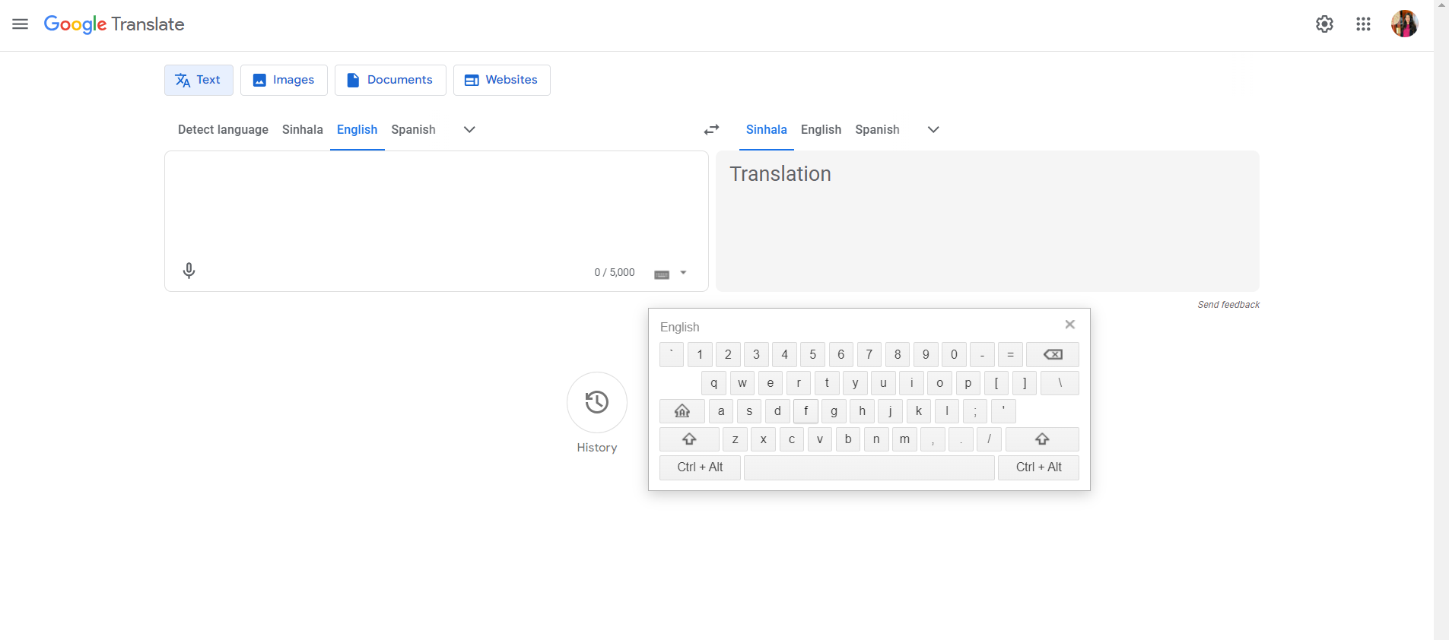

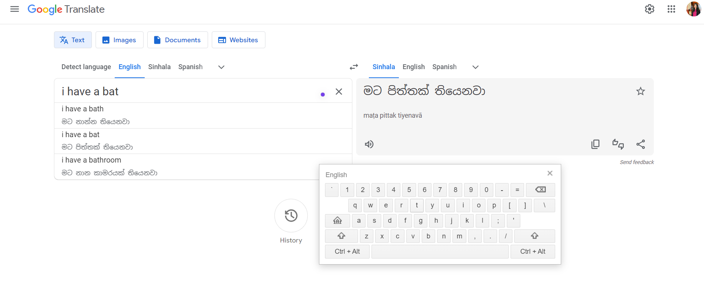

**Environment:**

**Operating System:** Windows 11

**Browser:** Google Chrome (Version 98.0.4758.102)

**Test Case Reference:** TC_TXTINPUT_17

**Title/Summary:** Functionality Test for Translation Sharing

**Bug ID/Reference Number:** BUG-004

**Severity/Priority:** High priority, Major impact

**Description:** The sharing option is set to an email address, but it does not open and does not share, although it appears there is a viewer error message.

**Steps to Reproduce:**

**Translated text, sharing option Email**

* The translation is shared via twitter the selected sharing option without any errors.After a translation is displayed, locate the "Share translation" section.
* Click on the "Share" button or equivalent option.
* Select the desired sharing option from the available choices (e.g., email, Twitter).
* If selecting email, enter the recipient's email address in the provided field.
* If selecting Twitter, log in to the Twitter account if prompted.
* Enter any additional message or comment if required.
* Click on the "Share" or equivalent button to initiate sharing.
* Verify that the translation is successfully shared via the selected option.

**Screenshots/Attachments:**

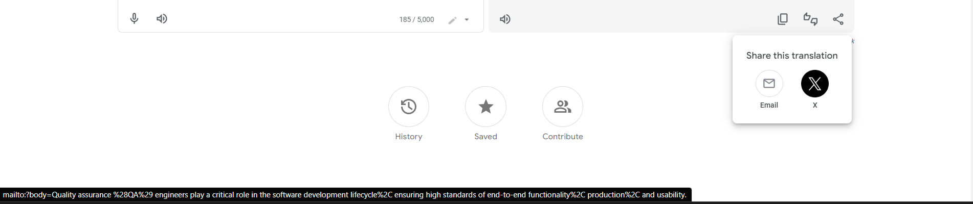

**Environment:**

**Operating System:** Windows 11

**Browser:** Google Chrome (Version 98.0.4758.102)

**Test Case Reference:** TC_FEEDBACK_29

**Title/Summary:** Issue with Image Translation Web Page UI

**Bug ID/Reference Number:** BUG-005

**Severity/Priority:** High priority, Major impact

**Description:**

The UI for image translation on the web page is not user-friendly and exhibits inconsistencies. Some icons and images appear misleading and do not function as expected. For instance, the cloud icon with the drag and drop feature indicated in text suggests the ability to drag and drop images onto the cloud. However, this functionality is not supported. Additionally, while the input section lacks drag and drop functionality, the translation side offers options for choosing a file and pasting from the clipboard.

**Steps to Reproduce:**

1. Navigate to the image translation section of the web page.
2. Observe the UI elements, including icons and images.
3. Attempt to drag and drop an image onto the cloud icon.
4. Compare the options available in the input section and the translation side for uploading images.

**Screenshots/Attachments:**

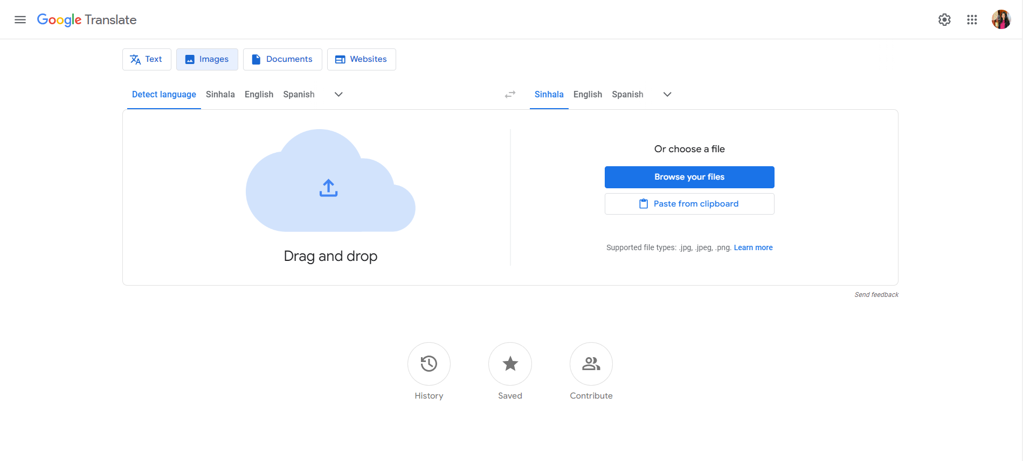

**Environment:**

**Operating System:** Windows 11

**Browser:** Google Chrome (Version 98.0.4758.102)

**Test Case Reference:** TC_LOAD_IMAGE_06

**Additional Information:**

The inconsistency in UI elements and functionality impacts the user experience and may lead to confusion regarding image upload methods.

**Title/Summary:** Issue with Translate Document Web Page UI

**Bug ID/Reference Number:** BUG-006

**Severity/Priority:** High priority, Major impact

**Description:**

The Translate Document web page UI lacks user-friendliness and contains misleading elements. For instance, the presence of a cloud icon with drag and drop functionality suggested in the input section may lead users to believe they can upload documents by dragging and dropping. However, this functionality is not supported. Additionally, the absence of clear instructions or visual cues may further confuse users. Conversely, on the translation side, the option to choose a file is provided, but it lacks consistency with the input section.

**Steps to Reproduce:**

1. Navigate to the Translate Document web page.

2. Observe the input section for any drag and drop functionality or cloud icons.

3. Attempt to drag and drop a document into the input section cloud icon.

4. Note the absence of expected drag and drop functionality.

5. Compare the input section with the translation side to identify discrepancies in file upload options.

**Screenshots/Attachments:**

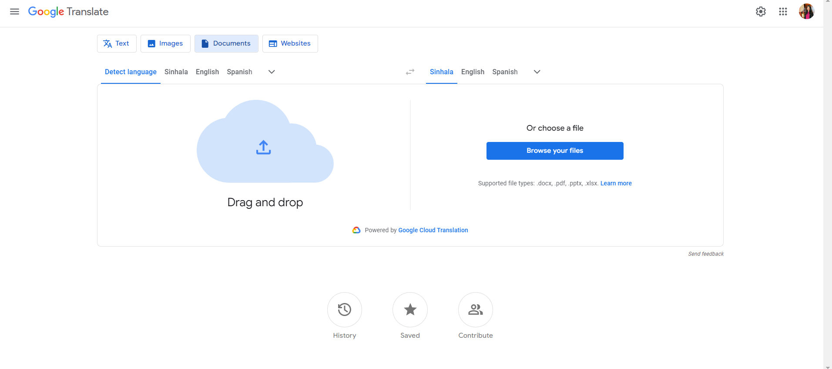

**Environment:**

**Operating System:** Windows 11

**Browser:** Google Chrome (Version 98.0.4758.102)

**Test Case Reference:** TC_LOAD_DOC_07

**Additional Information:**

The inconsistent UI elements and lack of clarity in the Translate Document web page may lead to user confusion and hinder the efficient use of the translation feature.

**Title/Summary:** Issue with Auto-Detect Language Functionality in Document Translation

**Bug ID/Reference Number:** BUG-007

**Severity/Priority:** Medium priority, Moderate impact

**Description:**

The auto-detect language functionality in the document translation feature is not functioning as expected. Despite the document being in English, the auto-detect feature fails to recognize the language accurately. This issue affects the accuracy of the translation and may lead to incorrect translations or user frustration.

**Steps to Reproduce:**

1. Navigate to the document translation feature of Google Translate.

2. Upload a document written in English.

3. Observe the language detection process.

4. Note any inaccuracies or failures in language detection.

5. Verify if the detected language matches the actual language of the document.

**Screenshots/Attachments:**

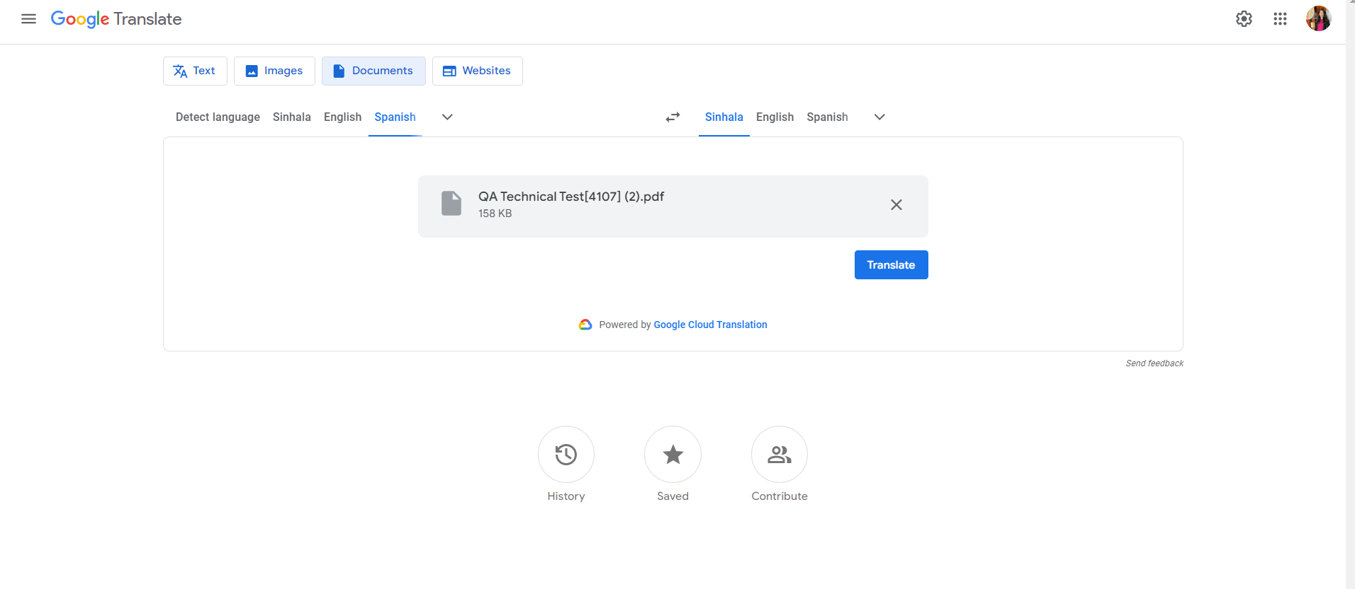

**Environment:**

**Operating System:** Windows 11

**Browser:** Google Chrome (Version 98.0.4758.102)

**Test Case Reference:** TC_TRANS_DOC_03

**Additional Information:**

The failure of the auto-detect language feature in document translation can result in inaccurate translations, impacting the overall user experience and the reliability of the translation service.

**Title/Summary:** User Interface Issue on Mobile Devices

**Bug ID/Reference Number:** BUG-008

**Severity/Priority:** Low priority, Minor impact

**Description:**

The user interface (UI) of Google Translate on mobile devices appears to be less intuitive and lacks optimal design. Specifically, the layout arrangement is not user-friendly, as essential elements are not positioned effectively for convenient use. On the mobile UI, the input language selection, translation language selection, and swap button are located at the top, while the input section and translated text are placed below. This arrangement may lead to confusion and inconvenience for users, affecting the overall usability of the mobile application.

**Steps to Reproduce:**

1. Access Google Translate on a mobile device.

2. Note the arrangement of elements on the UI, including input language selection, translation language selection, swap button, input section, and translated text.

3. Evaluate the ease of use and intuitiveness of the UI layout.

4. Compare the mobile UI layout with the desktop version for consistency and optimization.

**Screenshots/Attachments:**

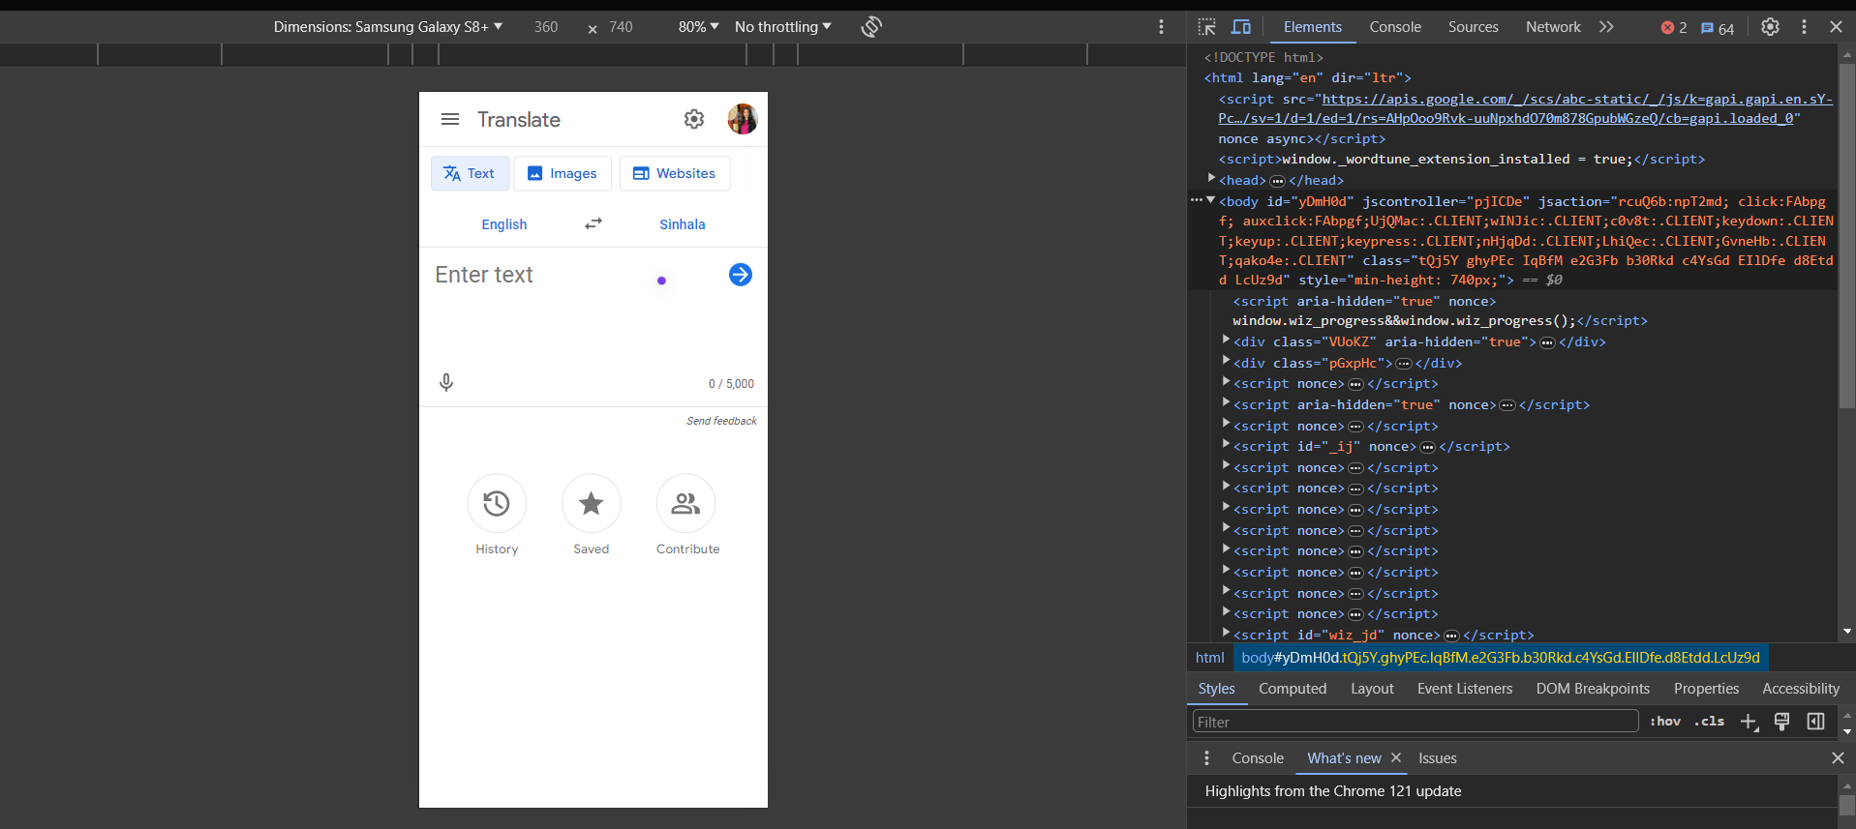

**Environment:**

**Device:** Mobile device (e.g., Samsung Galaxy S8+)

**Operating System:** Android or iOS

**Test Case Reference:** TC_UI_MOBILE_01

**Additional Information:**

The suboptimal UI layout on mobile devices may impact user experience and satisfaction. Improving the layout and organization of elements can enhance usability and make the application more user-friendly.

**Title/Summary:** Navigation Issue on Mobile UI About Page

**Bug ID/Reference Number:** BUG-009

**Severity/Priority:** Medium priority, Moderate impact

**Description:**

On the mobile user interface (UI) of Google Translate, there is a navigation issue observed on the About page. When accessing the About page from the mobile UI, there is no option to navigate back to the translation page or the main dashboard. Additionally, the Google Translate icon at the top of the About page, which typically serves as a logo or home button, redirects users back to the same About page instead of the translation page. This navigation inconsistency disrupts the user experience and makes it challenging for users to return to the translation functionality seamlessly.

**Steps to Reproduce:**

1. Access Google Translate on a mobile device.

2. Navigate to the About page from the mobile UI.

3. Attempt to navigate back to the translation page or the main dashboard.

4. Click on the Google Translate icon at the top of the About page.

**Screenshots/Attachments:**

**Environment:**

**Device:** Mobile device (e.g., smartphone)

**Operating System:** Android or iOS

**Test Case Reference:** TC_UI_MOBILE_ABOUT_01

**Additional Information:**

The lack of a back option or proper navigation functionality on the About page impedes user navigation and can lead to frustration. Providing a consistent and intuitive navigation experience is essential for enhancing user satisfaction and usability.

**Title/Summary:** UI Alignment Issue on Mobile Devices

**Bug ID/Reference Number:** BUG-010

**Severity/Priority:** Low priority, Minor impact

**Description:**

On mobile devices, there is an issue with the alignment of the main menu list, causing the UI elements to appear misaligned or shuffled. When viewing the Google Translate web page on a mobile device, the main menu list is displayed below the main dashboard, resulting in an unbalanced layout and inconsistent UI presentation. This alignment issue disrupts the visual coherence of the page and may lead to user confusion or difficulty navigating the interface.

**Steps to Reproduce:**

1. Access the Google Translate web page on a mobile device.

2. Observe the alignment of the main menu list relative to the main dashboard.

3. Note any misalignment or shuffling of UI elements.

**Screenshots/Attachments:**

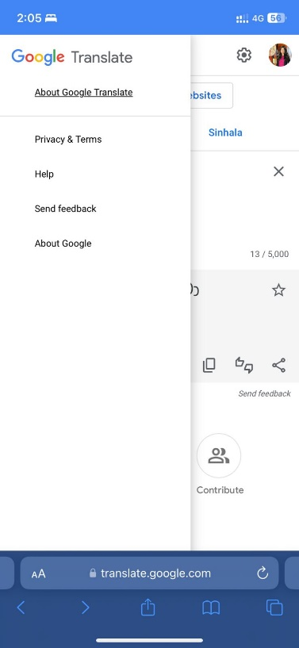

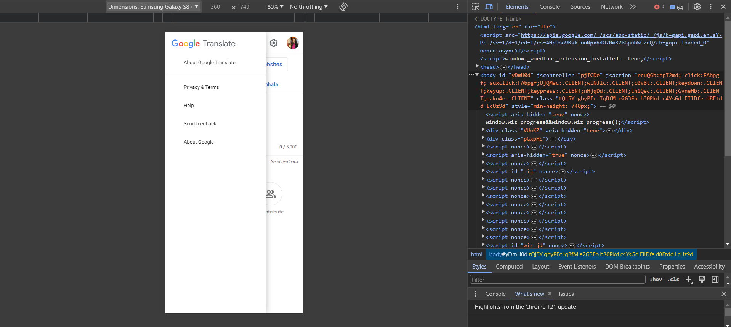

**Environment:**

**Device:** Mobile device (e.g., smartphone, tablet)

**Operating System:** iOS, Android

**Browser:** Mobile web browser (e.g., Chrome, Safari)

**Test Case Reference**: TC_UI_MOBILE_ALIGNMENT_01

**Additional Information:**

Resolving the alignment issue on mobile devices is essential for ensuring a consistent and visually appealing user experience across different screen sizes. Improving the UI alignment will enhance the usability and accessibility of the Google Translate web page for mobile users.

**Title/Summary:** Navigation Issue on Mobile UI About Page

**Bug ID/Reference Number:** BUG-011

**Severity/Priority:** Medium priority, Moderate impact

**Description:**

On the mobile user interface (UI) of Google Translate, there is a navigation issue observed on the About page. When accessing the About page from the mobile UI, there is no option to navigate back to the translation page or the main dashboard. Additionally, the Google Translate icon at the top of the About page, which typically serves as a logo or home button, redirects users back to the same About page instead of the translation page. This navigation inconsistency disrupts the user experience and makes it challenging for users to return to the translation functionality seamlessly.

**Steps to Reproduce:**

1. Access Google Translate on a mobile device.

2. Navigate to the About page from the mobile UI.

3. Attempt to navigate back to the translation page or the main dashboard.

4. Click on the Google Translate icon at the top of the About page.

**Screenshots/Attachments:**

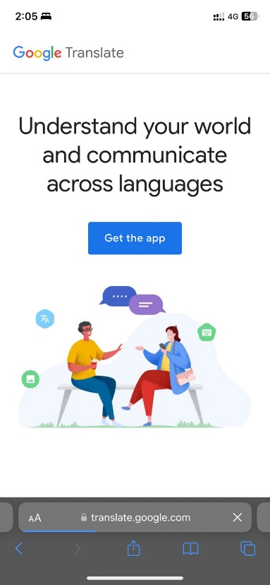

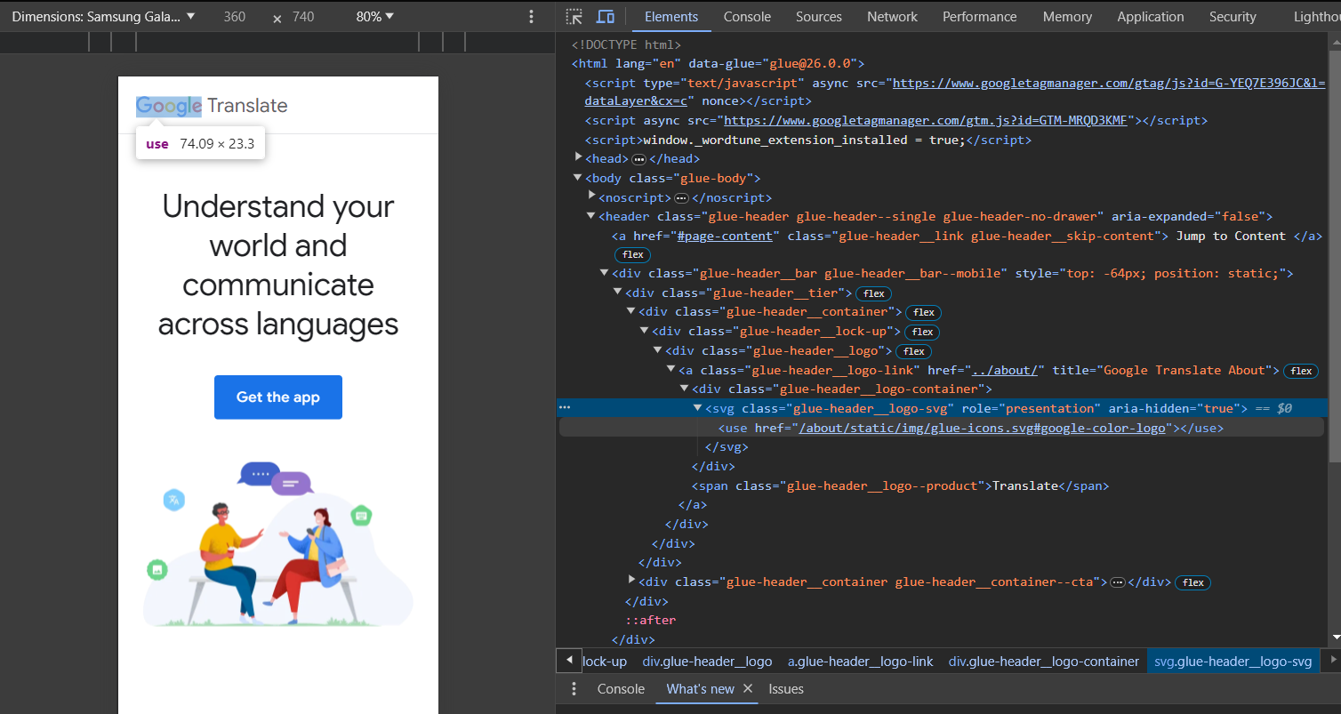

**Environment:**

**Device:** Mobile device (e.g., smartphone)

**Operating System:** Android or iOS

**Test Case Reference:** TC_UI_MOBILE_ABOUT_01

**Additional Information:**

The lack of a back option or proper navigation functionality on the About page impedes user navigation and can lead to frustration. Providing a consistent and intuitive navigation experience is essential for enhancing user satisfaction and usability.